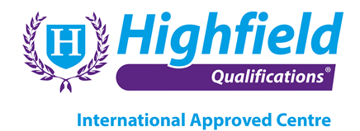

**ALLERGENS**

**Highfield Level 3 Award in Food Allergen Management in Catering (RQF)**

The objective of this qualification is to support a role in the workplace and is aimed at all operatives responsible for purchase, delivery, production and service of food in the hospitality and catering industry. It is also suitable for those owning/managing a smaller hospitality or catering business.

Learners achieving this qualification will have knowledge and understanding relating to the control of food ingredients, including allergens, at all stages of food purchase and production.

**Unit Standards**

**Unit 1 – Introduction Allergic Reactions, Symptoms, Treatments, Demographics and Statistics**

**Unit 2 – Common Allergens**

**Unit 3 – Allergen Legislation & Guidance**

**Unit 4 – Pre-requisites for good hygiene practice & Allergen control**

**Unit 5 – Practical control measures from Supplier to Consumer**

**Unit 6 – Staff Training**

**Unit 7 – Allergen Policies and verification methods**

**Pre-requisite Qualification**

**Highfield Level 2 Food Safety in Catering (RQF) or suitable equivalent.**

**Assessment Methods**

This qualification is assessed through a 1 hour, 30 question multiple-choice examination. Learners must achieve 60% in order to pass.

**How long will it take me to achieve this qualification?**

The total qualification time for this qualification is 2 days of guided learning.

**Where can this course be taken?**

Baobab Development Solutions – Cape Town – South Africa

Qualification Number: 603/1720/6 Credit Value: 1